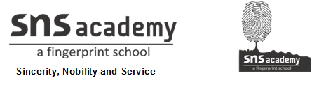

SOCIAL STUDIES

GRADE: V DATE: 24.6.20

1. KNOW YOUR PLANET

I.ANSWER THE FOLLOWING

1. How was it proved that the Earth is spherical in shape?

Ferdinand Magellan first sailed around the world and proved that the Earth is round. Pictures taken from space have also proved that the Earth is like a sphere.

2. How is the globe useful to us?

- A globe shows the distribution of land and water on the surface of the Earth.

- The correct shape, size and location of continents and oceans on the Earth can also be seen on a globe

3. How do maps help us? Why is a map less accurate than a globe?

- Maps are drawn on flat surface. We can show continents countries, cities and neighbourhoods on the Map.

- Maps cannot be used to show the spherical Earth because curved surfaces cannot be shown accurately on a flat surface. That is why a map is less accurate than a globe.

4. What are the features that help us to read a map?

The features which help us to read a map are directions. Scale, symbols and colours.

5. What are the different types of maps?

The different types of maps are
- Political map
- Physical map and
- Climatic map

6. What are the different colours used in the map?

The different colours used in the map are
- Brown – Mountains
- Blue - Water
- Green - Plains
- Yellow - Desert

7. Write any two differences between Globe and Map.

Globe | Map
It is difficult to carry. | Easy to carry.
Only one half of the Earth can be seen. | Whole Earth cane be seen.

8 .What is a scale?

The ratio between the distance on a map and the actual distance on the ground is called scale.

9. What is Atlas?

A book of maps is called an atlas.

10. The Earth looks mostly blue when seen from space. Why?

